5.2.3 Average Value

Motivation: How do you compute the average of four numbers: a, b, c, & d ?

This is simply done by calculating .

Now suppose that we wish to compute the average y-value of a function. Using the previous idea to compute such an average is much more difficult, because most functions of interest have infinitely many y-values. So, how would approach such a question?
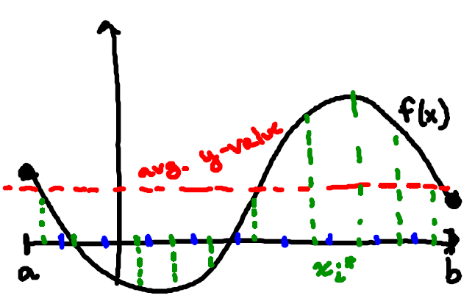
Suppose we have a continuous function defined on the interval . We can begin by dividing up the interval into n equal subintervals each with length . If we choose sample points each from the ith interval, then we can approximate the average y-value by calculating:

We should note that since then we can say that and if we use this in above calculation we have:

Therefore, we would expect that the exact average value ought to be:

We recognize this as a definite integral!!!

Definition: The average value of f on is:

Example 1: Find the average value of the function on the interval .

We can use geometry to find the area under on the interval .
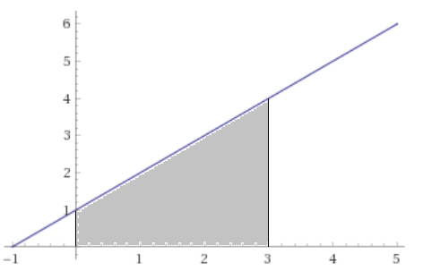

Therefore we have.

Example 2: Find the average value of the function on the interval .

We can use geometry to find the area under on the interval .

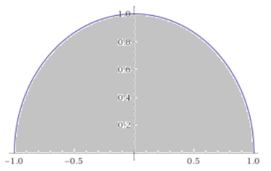

Therefore we have.

Question: If we are always finding the average value of a continuous function, must it be the case that there is a value of x where ?

Intuitively this seems true. If the function is continuous it would have to pass through (at some point) the y-value that is the calculated to be .

The next theorem makes this idea precise.
Theorem (The Mean Value Theorem for Integrals): If f is continuous on , then there exists a number c in such that:

Proof:

Since f is given as a continuous function on , then by the Extreme Value Theorem f has an absolute maximum value M and an absolute minimum value m on the interval .

Therefore we can say that .

This immediately implies that .

We calculate the outer integrals and obtain: .
If we divide everything by we obtain: .

But then, by the IVT, must equal for some value c in !

Therefore we can say that for some c in we have .

Example 3: Find all numbers c that satisfy the MVT for Integrals for the function on the interval .

Since is continuous on , the MVT for integrals states that there is a c in such that:

So we have .

Example 4: Find all numbers c that satisfy the MVT for Integrals for the function on the interval .

Since is continuous on , the MVT for integrals states that there is a c in such that:

So we have .

Both of these values are in the interval and so both of them are acceptable values of c.

Example 5: If f is a continuous function and , show that f takes on the value of 1.1 at least once on the interval .

Since f is continuous then by the MVT for integrals, there exists a c in such that:

Note: The Average Value of a function and the MVT for Integrals are powerful concepts that will help us to connect the various ideas of Calculus in what we call the Fundamental Theorem of Calculus!!!

